**PA FRF Product Order Sheet**

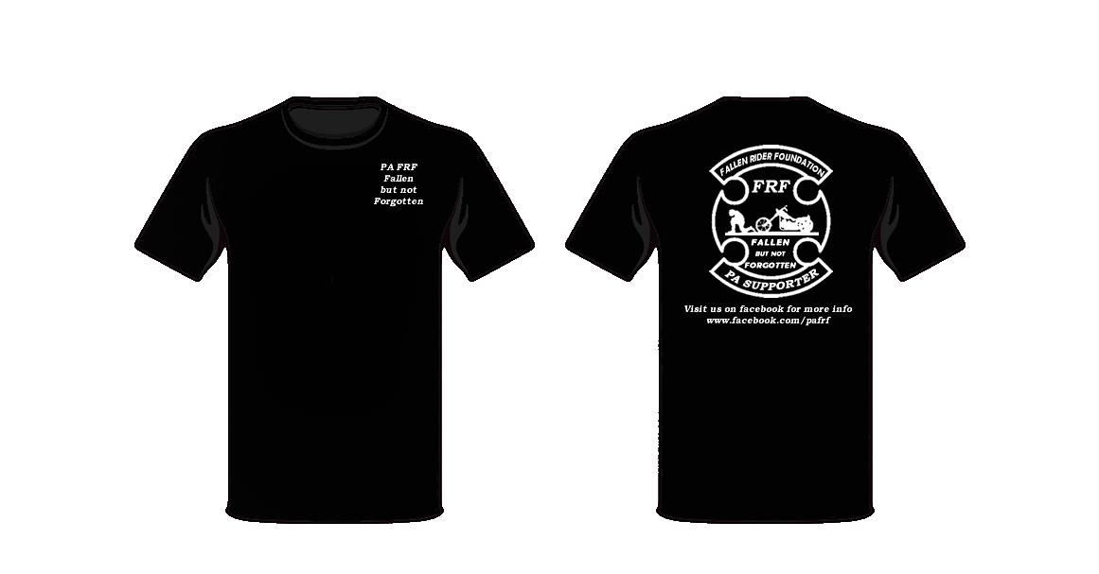The Fallen Riders Foundation is here to help the families of riders who are injured or killed while on their bike. We don’t care if you are a club member or an independent. If you go down, and your family needs help, that’s where we come in. Please show your support.

**PA FRF Support Shirts**

**#T0051**

**$15 each**

*\*\*Stock availability varies, we*

*normally have Med, Lg, XL on hand.*

*Small or XXL orders may be delayed.*

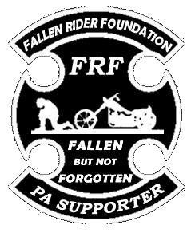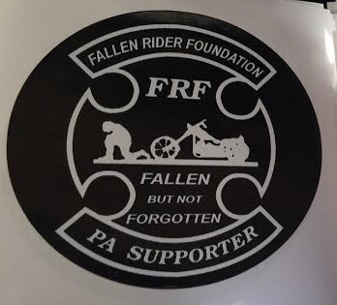**PA FRF Support Patch PA FRF Window Decal**

**#P0075 4.5”x 3.5” #S3432**

**$10 each $5 each**

**PA FRF Order**

|  |  |  |  |  |  |
| --- | --- | --- | --- | --- | --- |
| **Qty** | **Item Num** | **Size** | **Description** | **Price Each** | **Total** |
|  |  |  |  |  |  |
|  |  |  |  |  |  |
|  |  |  |  |  |  |
|  |  |  |  |  |  |
|  |  |  |  |  |  |
|  |  |  |  |  |  |
|  |  |  |  | **Grand Total** |  |

**Date: _______________**

**Name: ___________________ Organization: ________________**

**Address: ___________________________________________________**

**City: _______________ State: ___________ Zip: __________________**

**Phone: _____________________ Email: _________________________**

**MAIL WITH CHECK OR MONEY ORDER TO:**

**PA FRF**

**PO Box 110**

**Newton Hamilton, PA 17075**